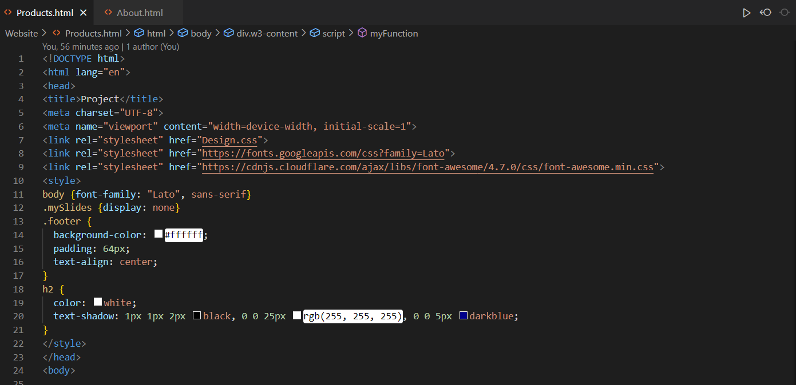

Products.html:

The stylesheet is connected to the CSS folder, containing the Design.css.

It displays the footer colour in the footer.

Also shows the second heading colour as well.

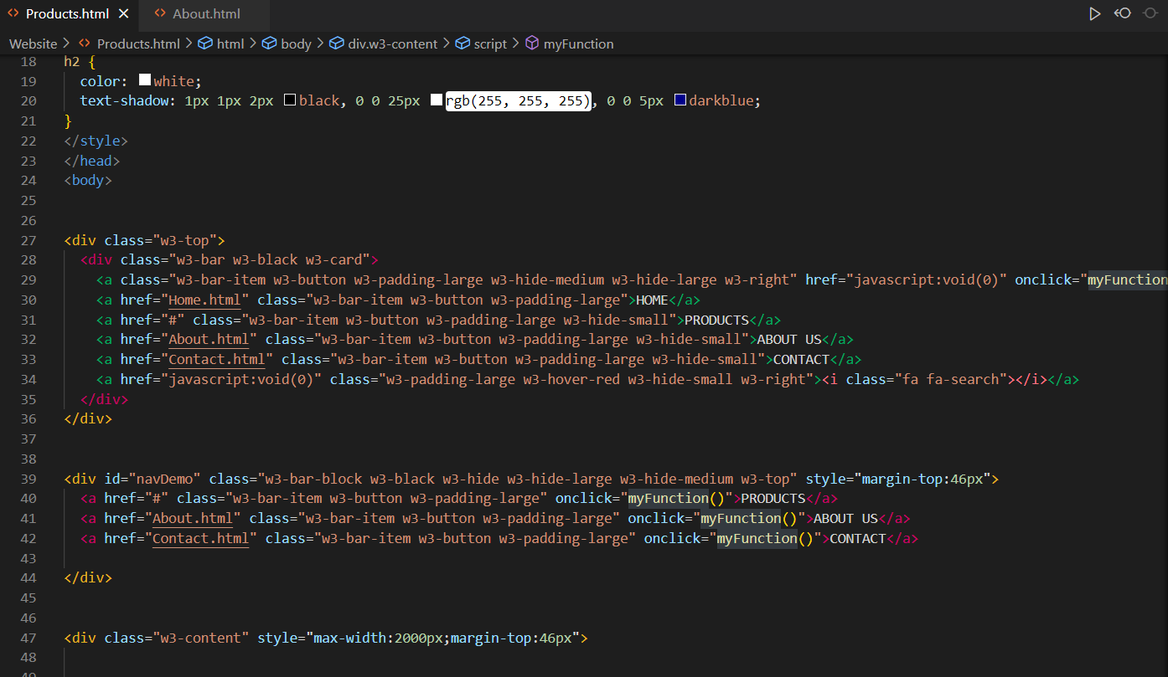

Above we have the Nav bar section, where all of the pages connect up to each-other. Took me a while to get it working fully. The # is where the page is located when it is opened through the home page, somewhat like a new homepage when clicked and opened to.

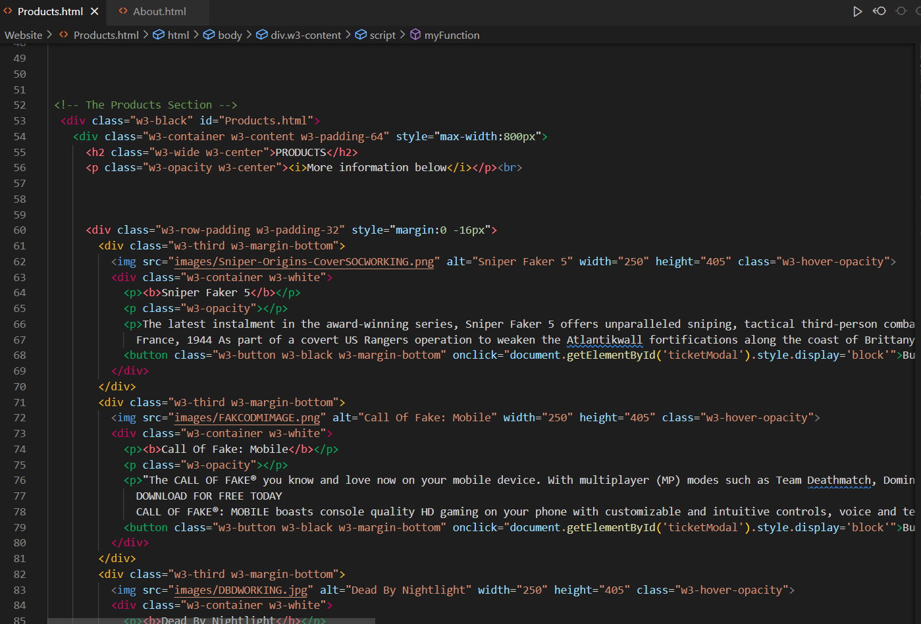

Above is the products section (products contents). Connects to the form with the buy now function. Image file paths are displayed correctly too.

Above is the buy now function that shows the form when clicked.

Above is the About us page.

Shows the contents above in a paragraph that’s easy to read.